Chapter 2: Displaying and Describing Categorical Data

Part II: Bar Chart and Pie Chart

**Titanic Example:**

1. **Graph bar chart:**
2. Open the data file (Titanic 1.csv). In this file, there is a relative frequency table.

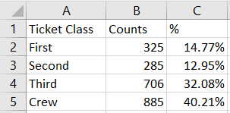

1. Select the range of the data set (the frequency table).

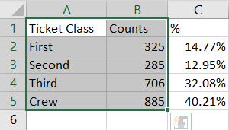

1. Select **Insert** tab $⟹$ **Insert Column or Bar Chart $⟹$**  **Clustered** **Column.**

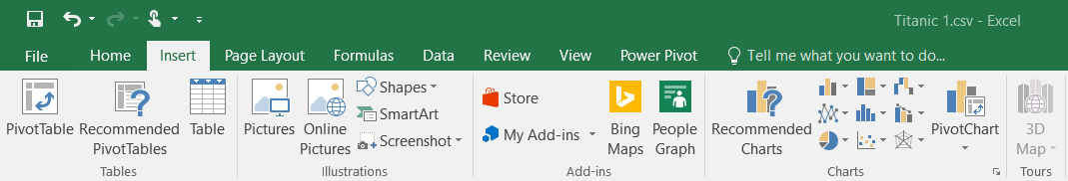

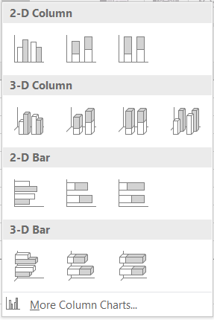

1. The result is the bar chart

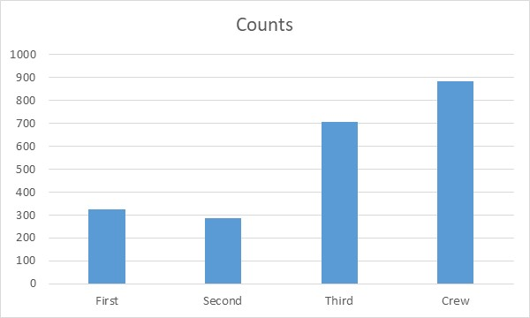

1. To add titles to X and Y axis, select **Design** tab $⟹$**Add Chart Element $⟹$** **Axis Titles $⟹$** **Primary Horizontal** for X axis and **Primary Vertical** for Y axis.

Write the title for each axis.

You can write your own graph title by click on the title (Counts) in the graph.

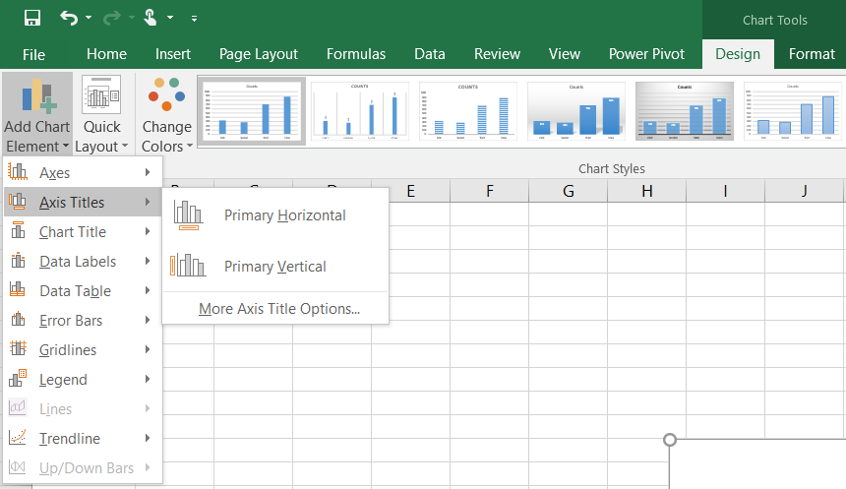

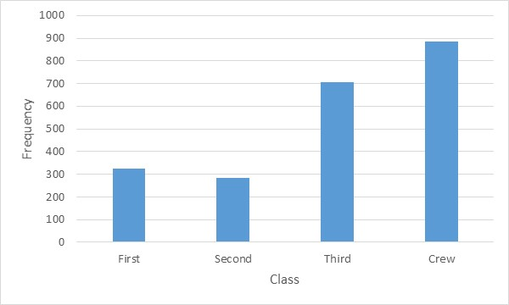

1. To graph the relative frequency table, we can follow the same steps, but we need to delete counts column in the relative frequency table, or we select the whole table

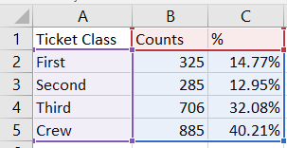

The result is the following graph, which is not a right graph.

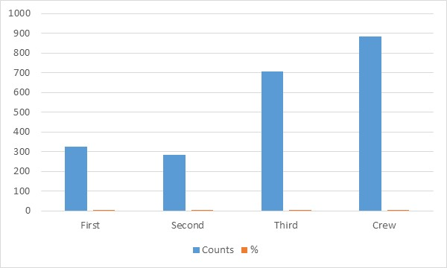

1. Select the graph and use the **mouse right click**, then click on **Select Data**.

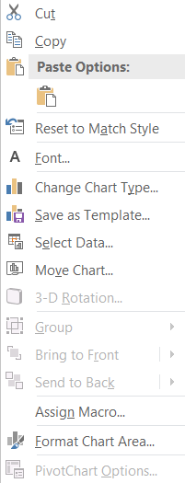

1. Dialog box **(Select Data Source)** will open; in the **Legend Entries** (**Series**), select Counts and click **Remove**, then click **OK**.

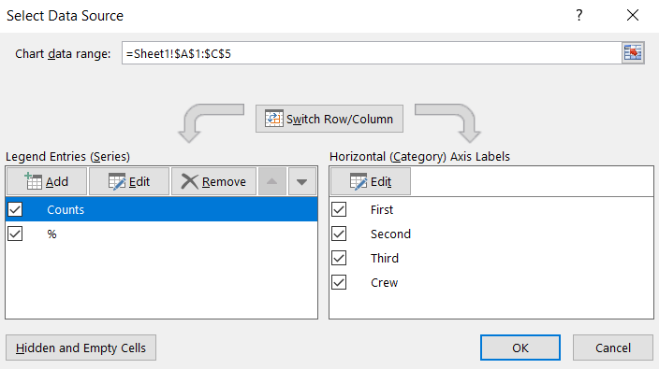

1. The result is the bar chart of the frequency table

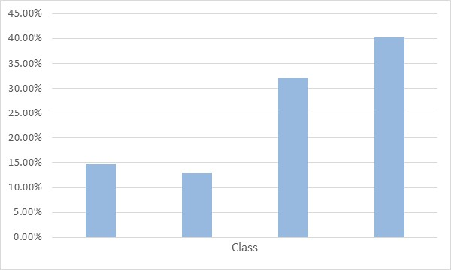

1. You can add the titles to X and Y axis by following the same steps in the frequency bar graph.
2. **Graph Pie chart:**
3. Select the range of the data set.



1. Select **Insert** tab $⟹$**Insert** **Pie or Doughnut Chart $⟹$**  **2 D Pie.**

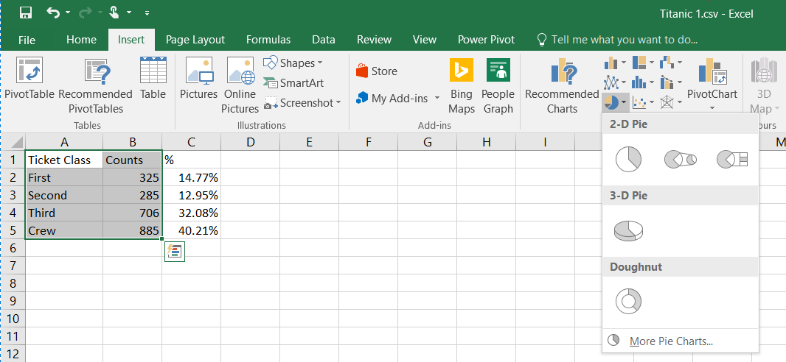

1. The result is

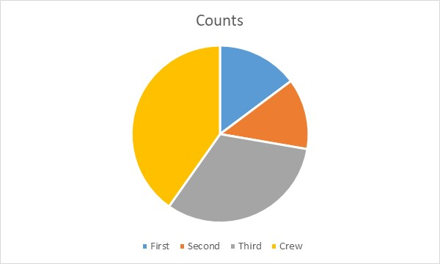

1. To type the label for each piece and, count, and percentage, select **Design** tab $⟹$**Add Chart Element $⟹$** **Data Labels $⟹$** **More Data Label Options**.

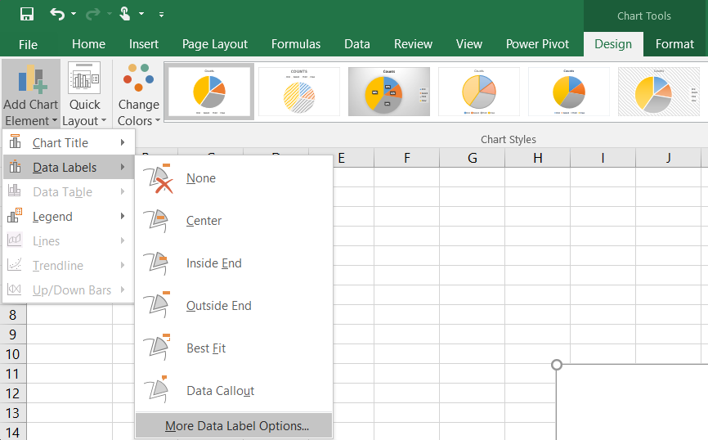

1. **Format Data Labels** dialog will appear on your right, select **category name**, **value**, and **percentage**.

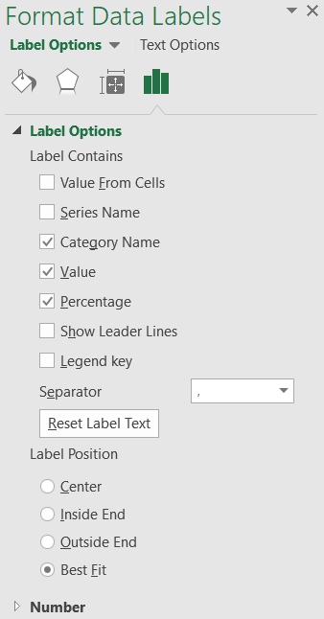

1. The result is

